DAY 3 REPORT
Student Performance Analysis Dataset Expansion & Visualization
1.Expansion of the Dataset (Continuation of Day 2)
The Student Performance Analysis dataset was further analyzed and organized by categorizing the columns based on their importance and relevance for prediction and visualization purposes.

Available Columns in the Dataset
- id
- first_name
- last_name
- email
- gender
- part_time_job
- absence_days
- extracurricular_activities
- weekly_self_study_hours
- career_aspiration
- math_score
- history_score
- physics_score
- chemistry_score
- biology_score
- english_score
- geography_score
- grade (Output Column)

Column Separation
Must Needed Columns
These columns are essential for analysis and prediction because they directly influence student academic performance.
- gender
- absence_days
- weekly_self_study_hours
- math_score
- history_score
- physics_score
- chemistry_score
- biology_score
- english_score
- geography_score

Unwanted Columns
These columns were removed because they do not contribute to performance prediction.
- first_name
- last_name
- email

Optional Columns
These columns may provide additional insights but are not mandatory.
- id
- part_time_job
- extracurricular_activities
- career_aspiration
2. Visualization of the Data
Data visualization was performed using CanvasJS to represent student performance in graphical format.
CANVAS JS
CanvasJS Official Website
CanvasJS was used for creating interactive and responsive charts to analyze the dataset effectively.

Example Charts Created
1. Pie Chart Creation
Objective:
To represent the percentage distribution of student marks in each subject.
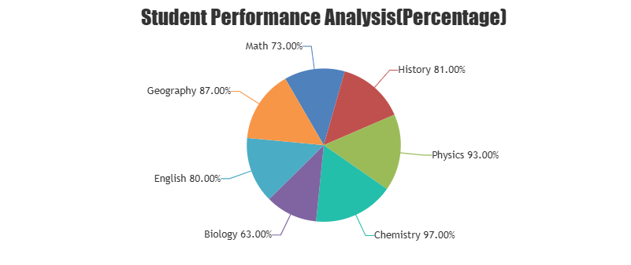

2. Bar Chart Creation
Objective:
To compare average marks based on weekly self-study hours.
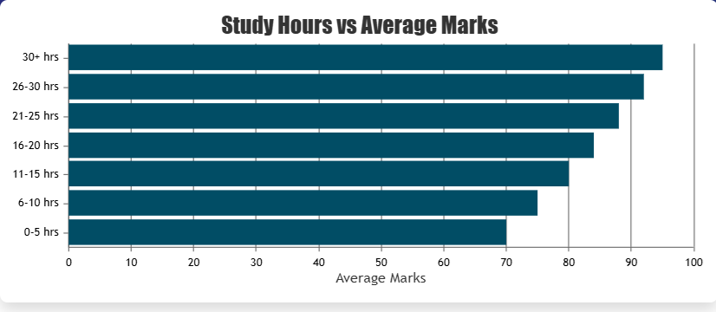

3. Line Chart Creation
Objective:
To represent variation in students’ marks based on absence days.
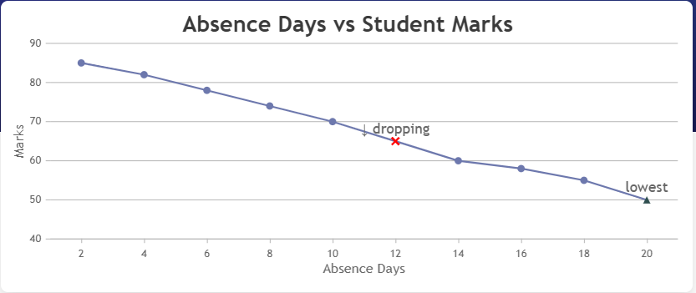

GOOGLE COLAB
Google Colab
Google Colab is an online platform used to write and execute Python programs through a web browser. It is mainly used for data analysis, machine learning, and visualization tasks.
Installing Modules
Required Python modules were installed using the pip install command for performing data analysis and visualization operations.

